Welcome to Sunseekers!

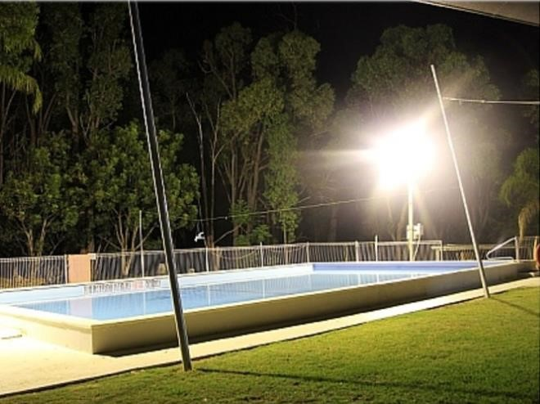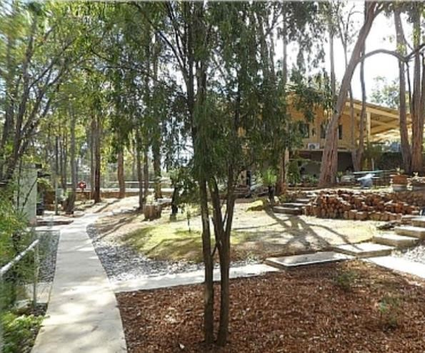
An Introduction to Social Nudism and Sunseekers

Of course, you’re curious about nudism. Most people are but you have, at least, taken the informed step that comes with learning.

The nudist idea is simple! The human body is completely natural and is not obscene as some in society would have you believe. Keeping certain body parts covered only creates mystique, even if it is more suggestive than actually covering. Think ‘string’ bikinis on a beach!

Nudists believe that the human body as a whole, is perfectly natural and comes in all shapes and sizes. Social nudism is nonsexual for families, couples and singles of all ages and genders.

Sunseekers is family orientated and there is a mix of activities for everyone.
We have a variety of sports activities from tennis, mini ten and volleyball for the outdoor enthusiast as well as pool, darts & table tennis for the indoor enthusiast. You can take a dip in the pool or spend your day lazily lounging in the shade or read a book from our inhouse library. You can even take in a movie in the lower club house. We have vast collection to choose from.

Our emphasis is placed on socialising. You can converse with other members or just relax in our natural bushland surroundings. Hang about longer and come along and join in our circle at ‘Sundowners’ (happy hour) or ask about our function nights. You can even book in for the night so you can enjoy a drink without fear of having to drive. The point is we are comfortable in our own skin, whatever activity we partake in. However, nudists are not anti-clothes. Many a function has a ‘dress up/down’ theme. The choice is yours.

There are many valid reasons you will see members wearing them onsite. For protection and safety when working on the grounds or when cold and windy.

The dress code is simple…clothed when practical…nude whenever possible!

For hygiene reasons, you should always carry a towel!

There are a few things that will help us make your visit as enjoyable as possible.
Your assistance in the following matters is greatly appreciated.

- Please sign the visitors’ book on arrival and upon leaving.
This is for fire and safety reasons (so we know who is still on site in case of fire) and the new Covid mandates. Under age visitors are the responsibility of the Parent/Guardian at ALL times.

- Under NO circumstances are cameras or photography allowed.
This is to ensure the privacy of both members and guests. (Official club event photographer exempt)

- Always carry a towel!
This is most important for hygiene as well as always having something to sit on.

- As a Nature Park, we have limited bin space.
If you live in the metropolitan area, taking all your rubbish home with you is greatly appreciated.

- Only nude swimming is permitted in the pool. (Children under 18 years excepted)
One may wear a T-shirt/Rash top for sun protection.
Toddlers MUST wear an appropriate “wet/swim” nappy/diaper.

- Exposed underwear is not permitted to be worn at the club.
We are a Nudist club, please respect this. At the same time, we do want you to be comfortable. If new to nudism, a sarong style tie or long over shirt is acceptable until you are ready.

- NO glass is permitted in or on the immediate concrete area around the pool.
Plastic/metal flutes and/or cups as well as coloured wine/beer bottles are allowed on the grassed area only.

- Be sun safe at all times! Time your skin exposure to avoid sunburn. Ask us for Sun Protection cream if you don’t have any with you.

- Fire and safety is paramount as we are a Nature Park with a bushland setting.
If you hear the fire bell, please follow members to the designated assembly area.

- Mozzies! They are always around.
We recommend the use of insect repellent.

- Dogs are currently allowed at Sunseekers (in specific areas only)
They must be contained within your allocated space or on a leash at all times.

- No mats are allowed on the lawn area.
This is to protect our lawn as grass matting tends to destroy the lawn

- Interested in joining the club? Application forms are available.
Please ask one of our live-in members, a committee member or it can be emailed to you via our secretary below.

- If you have any questions.
Please feel free to speak to our live-in members or any committee member for answers.
Contact details:

- Website: https://www.sunseekers.com.au
- Telephone: 0460 710 104
- Find us at: 480 Richardson Road, Hovea, WA 6071
- Email the secretary to book a visit: secretarysunseekers@gmail.com

Booking in is essential as we are a gated property, and you need a gate code to enter
Form created December 2021

